Name: Cameron L'Ecuyer  
Class ID: 17  
Email: [cjlth5@mail.umkc.edu](mailto:cjlth5@mail.umkc.edu)  
Professor: Yugyung Lee  
[MyGitHub](https://github.com/camlecuyer/CS5551_11-1_LabAssignments)

Technical Partner: Name: Sneha Mishra  
Class ID: 21  
Email: [smccr@mail.umkc.edu](mailto:smccr@mail.umkc.edu)  
[GitHub](https://github.com/SnehaMishra28/CS5551_SnehaMishra_labassignments/wiki/CS5551_(11_1)_LabAssignment_lab%234)

**Objective**

Create an Ionic based application with a login and register page, that makes use of two web services, and an Ionic plugin. There must also be test cases for the application, and have YSlow grading

**Features**

* Login and Register pages
* Two web services
* An Ionic plugin
* Test cases
* YSlow grading

**Steps**

**Step 1 - Create an Ionic application and create a login page and register page**

This image shows the login HTML, the register HTML is similar to the login 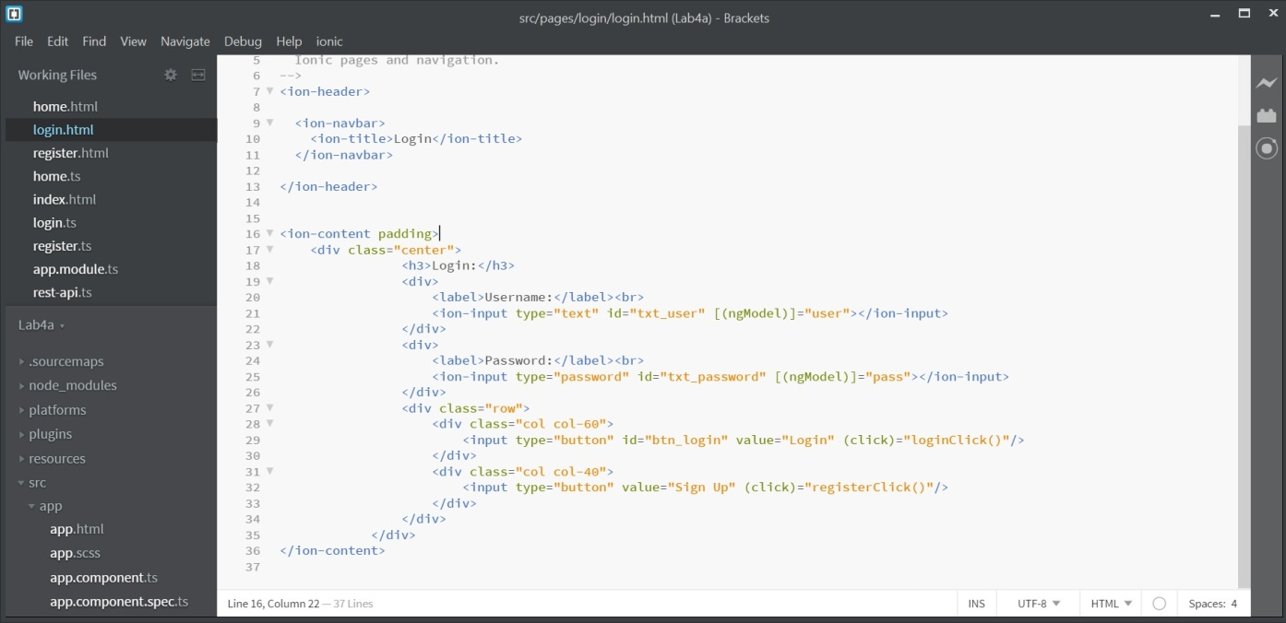

**Step 2 - Add code to verify the login/register and navigate to home**

This image shows some of the code for login, register is similar 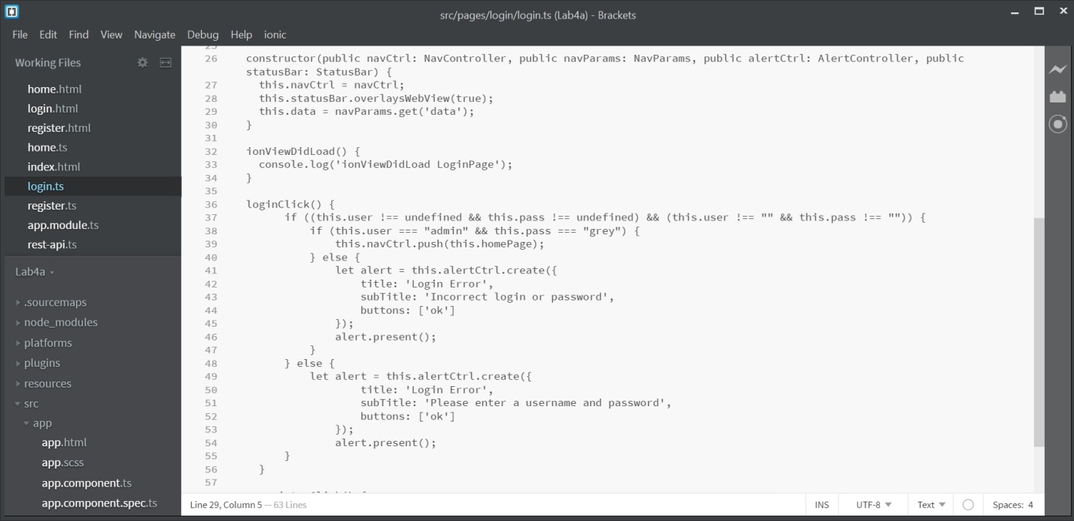

[Full login page data](https://github.com/camlecuyer/CS5551_11-1_LabAssignments/tree/master/Lab-4/Source/Lab4a/src/pages/login)

[Full register page data](https://github.com/camlecuyer/CS5551_11-1_LabAssignments/tree/master/Lab-4/Source/Lab4a/src/pages/register)

**Step 3 - Create a home page**

This image shows the home HTML 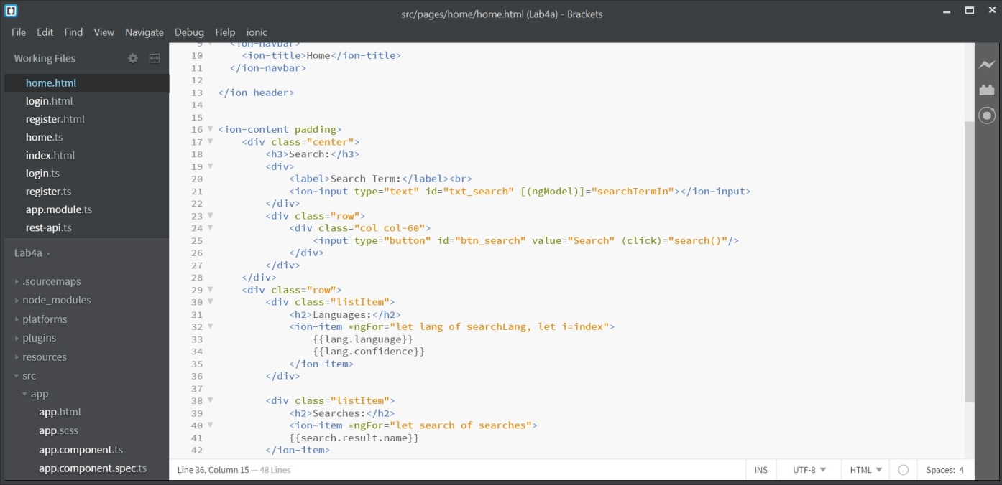

**Step 4 - Add code to the home page, and create and use a provider for API calls**

This image shows the code for the home page 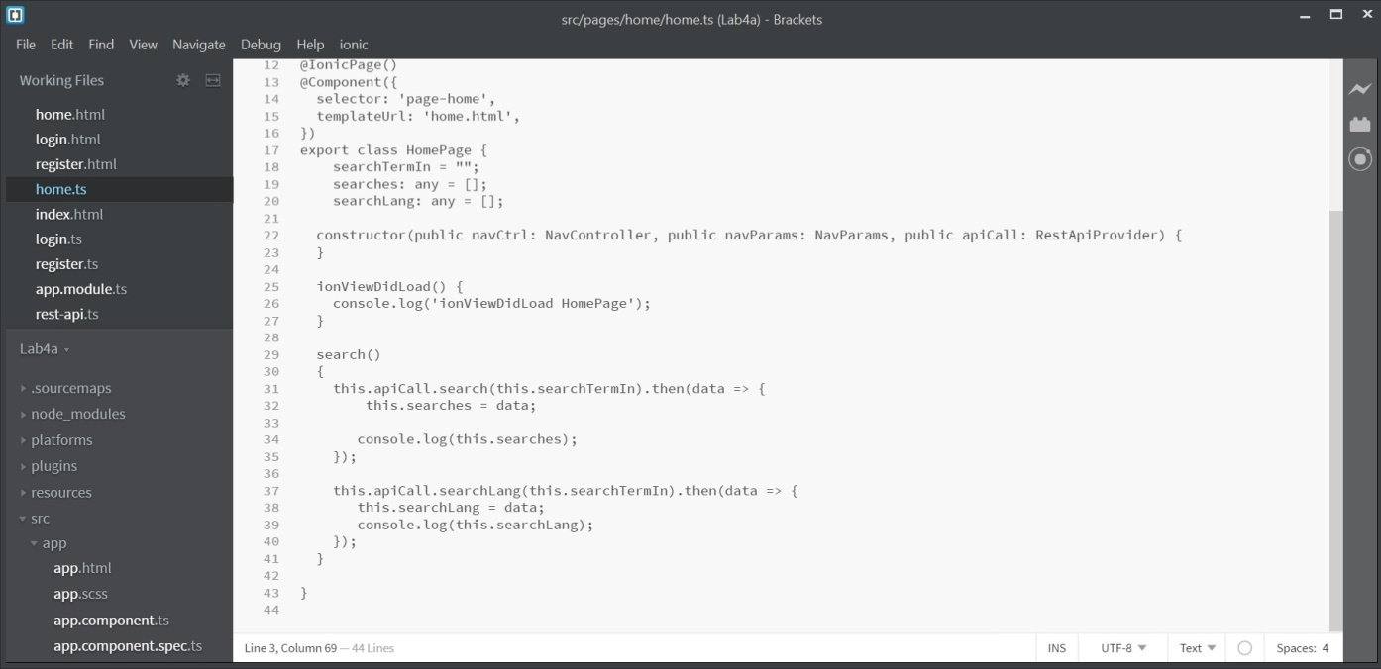

[Full home page data](https://github.com/camlecuyer/CS5551_11-1_LabAssignments/tree/master/Lab-4/Source/Lab4a/src/pages/home)

This image shows some of the code for the REST API calls 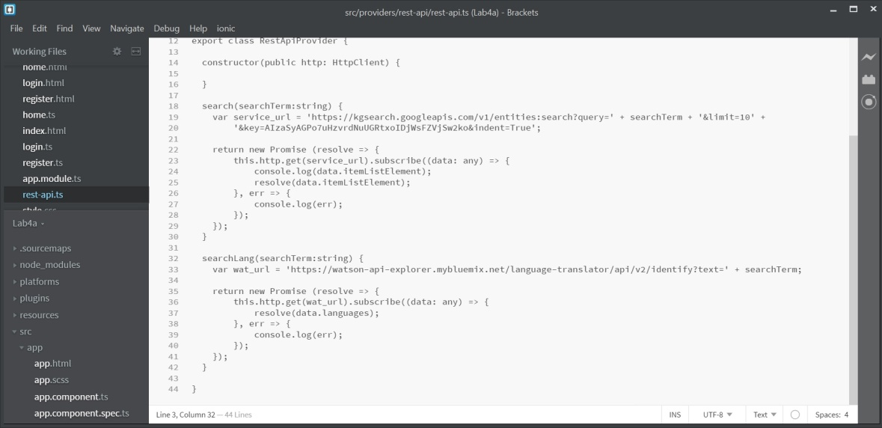

[Full REST API code](https://github.com/camlecuyer/CS5551_11-1_LabAssignments/blob/master/Lab-4/Source/Lab4a/src/providers/rest-api/rest-api.ts)

**Step 5 - Add an Ionic plugin**

This image shows the installation of the plugin 

**Step 6 - Run YSlow on all the pages**

This image shows the YSlow for Login 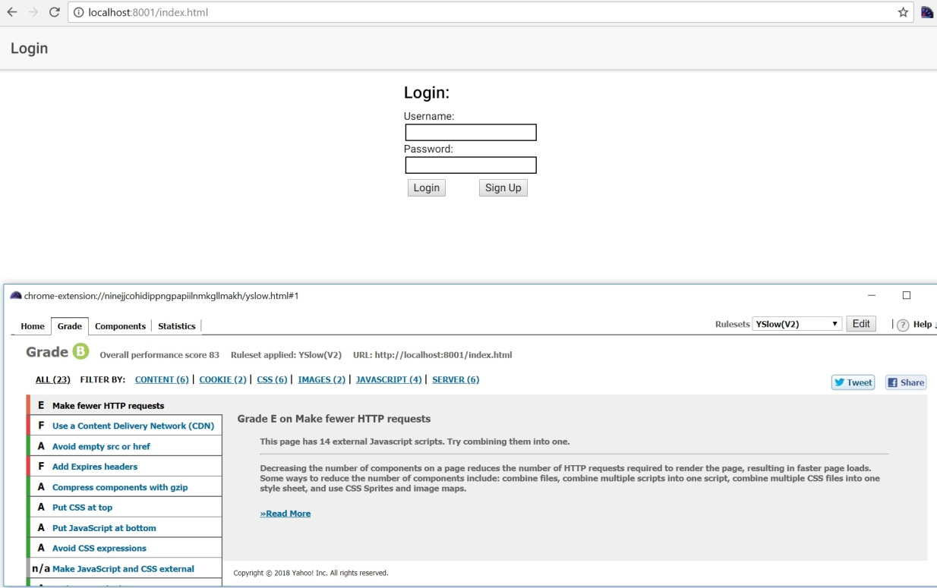

This image shows the YSlow for Register 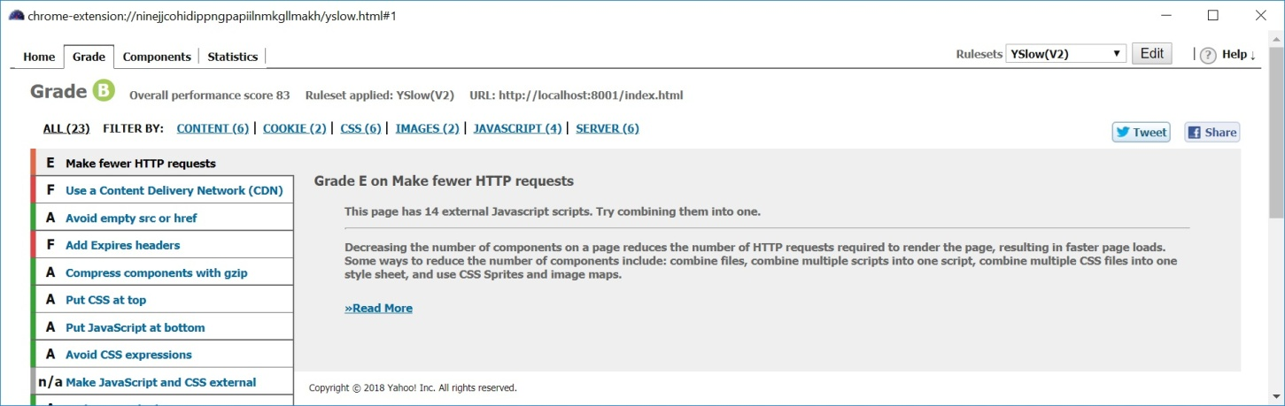

This image shows the YSlow for Home 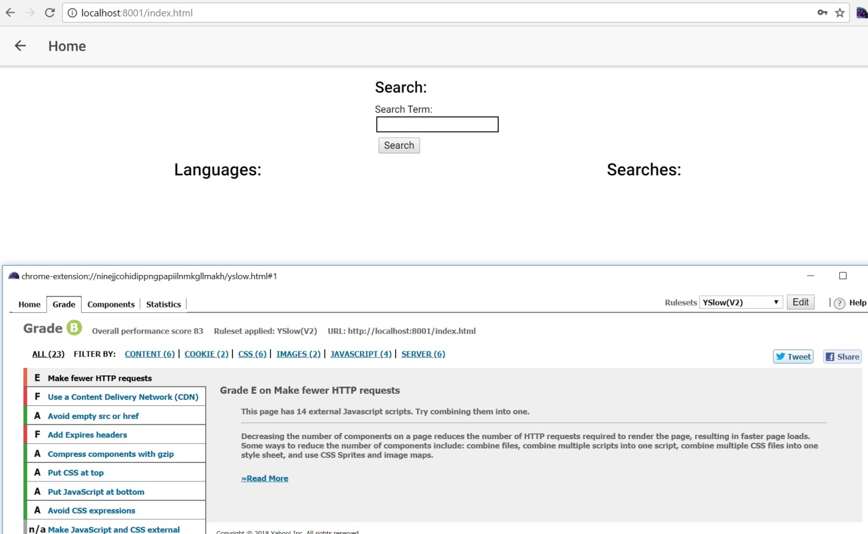

**Step 7 - Build test cases**

This image shows the test cases for the app 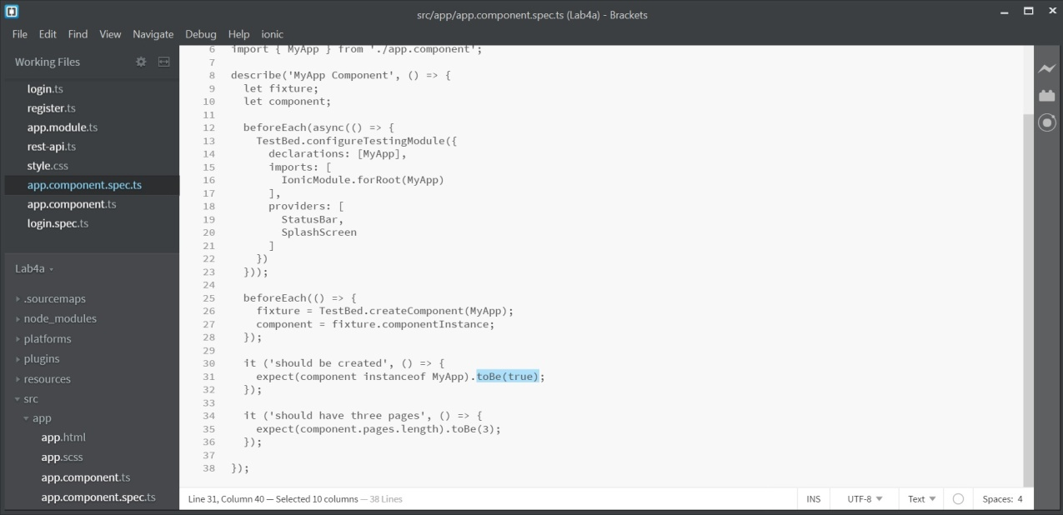

This image shows the test cases for app failing 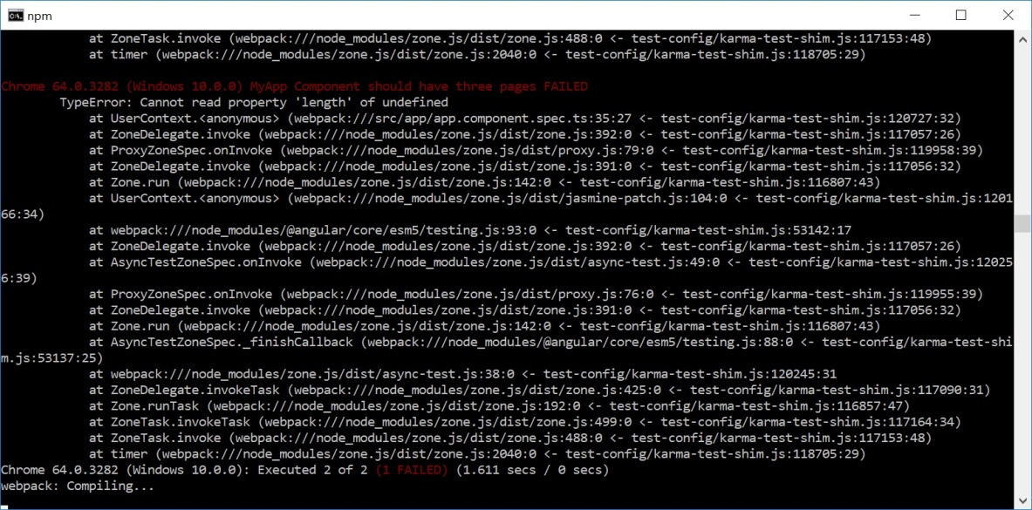

This image shows some test cases for login 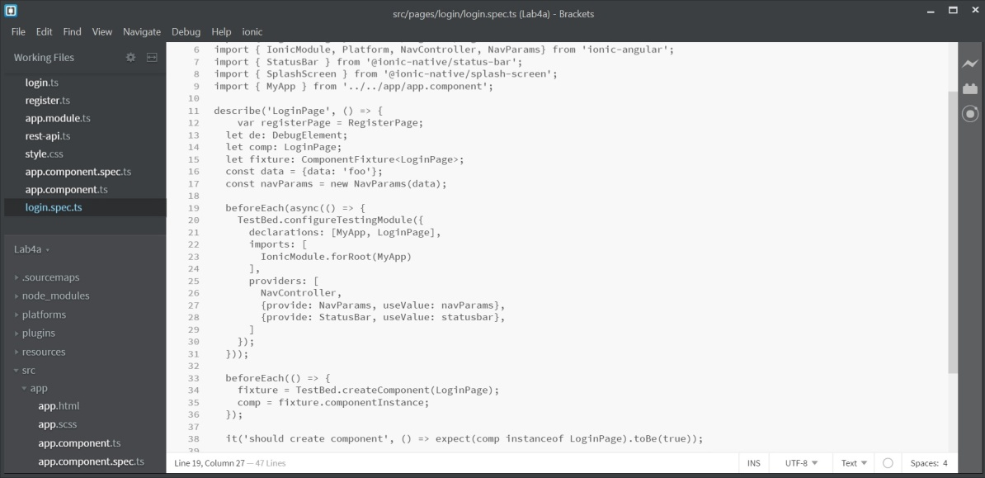

**Results**

This image shows the login page

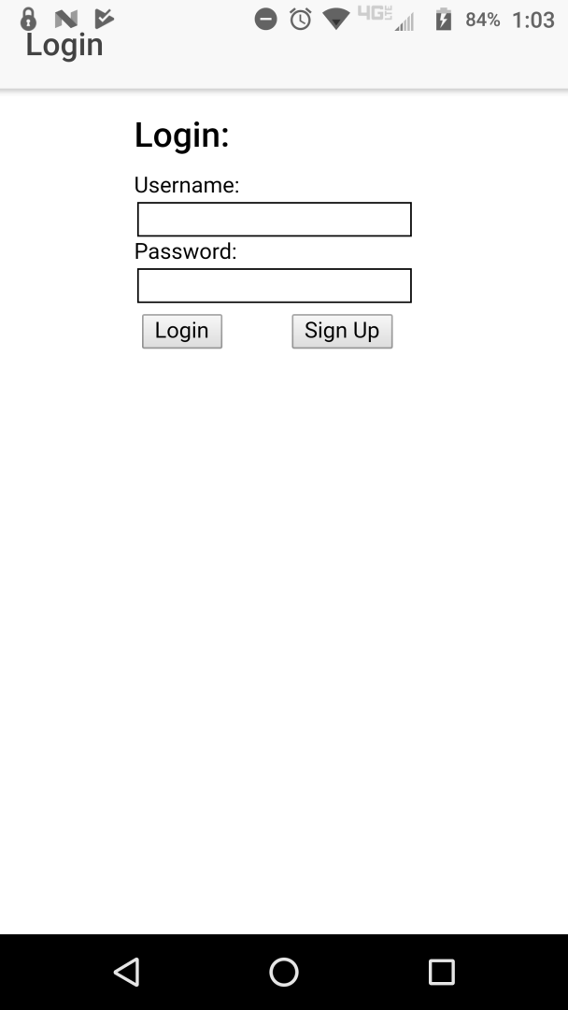

This image shows the register page

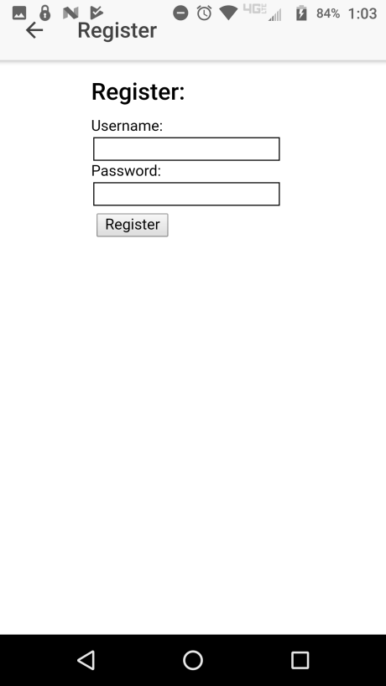

This image shows the home page before searching

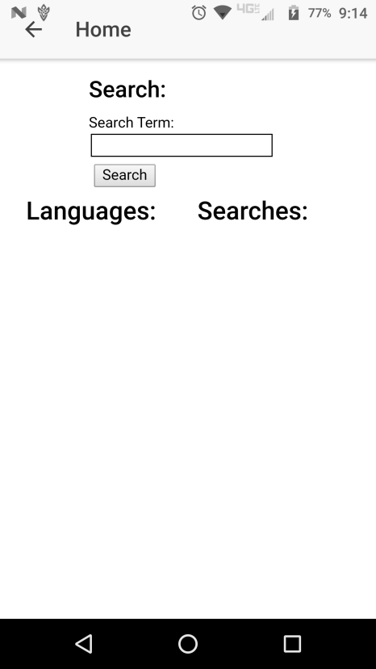

This image shows what the home page looks like after searching

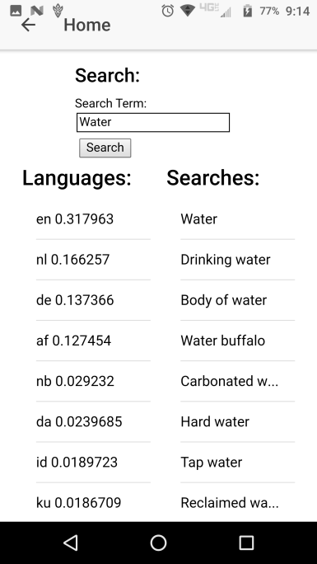

This image shows 3 successful tests 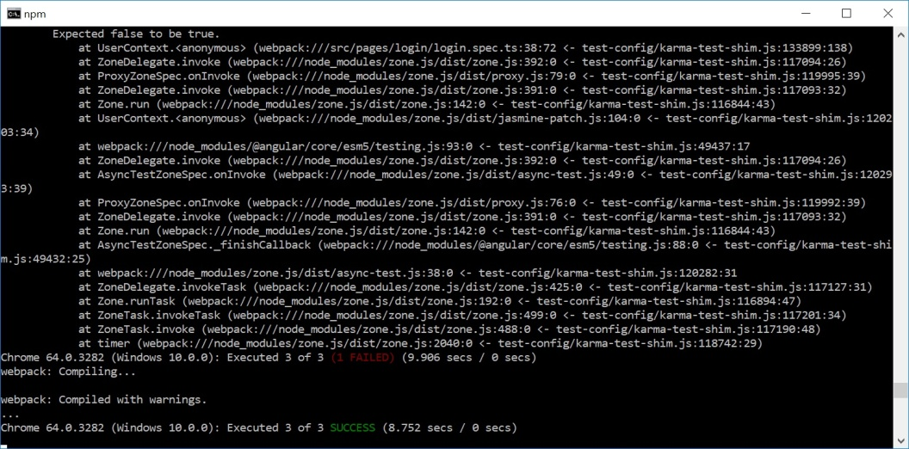

**References**

This showed how to use the Google Knowledge API: <https://developers.google.com/knowledge-graph/>  
This helped me to properly navigate with Ionic 3: <https://blog.ionicframework.com/10-minutes-with-ionic-2-adding-pages-and-navigation/>  
This helped me with retrieving data with Ionic 3: <https://forum.ionicframework.com/t/ion-input-get-value/86989>  
This was the plugin I used: <https://ionicframework.com/docs/native/status-bar/>  
This link helped me with using a provider and REST services with Ionic 3: <https://www.djamware.com/post/59924f9080aca768e4d2b12e/ionic-3-consuming-rest-api-using-new-angular-43-httpclient>  
This code helped me develop some tests: <https://github.com/ionic-team/ionic-unit-testing-example>